Customer Shopping Behavior
Analysis & Revenue Insights Report
Dataset: 3,900 Transactions

Executive Summary
This report presents a comprehensive analysis of customer shopping behavior using transactional data from 3,900 purchases across multiple product categories. The study encompasses revenue analysis, product ratings, shipping preferences, subscription behavior, category performance, and demographic insights — delivering actionable intelligence for strategic business decisions.

3,900  Total Customers | $59.76  Avg Purchase Amount | 3.75 / 5  Avg Review Rating

1. Project Overview
This project analyzes customer shopping behavior using transactional data from 3,900 purchases across various product categories. The goal is to uncover insights into spending patterns, customer segments, product preferences, and subscription behavior to guide strategic business decisions.

2. Dataset Summary
Attribute | Details
Total Rows | 3,900
Total Columns | 18
Customer Demographics | Age, Gender, Location, Subscription Status
Purchase Details | Item, Category, Amount, Season, Size, Color
Shopping Behavior | Discount, Promo Code, Previous Purchases, Review Rating, Shipping Type
Missing Data | 37 values in Review Rating column (imputed using median per category)

3. Exploratory Data Analysis & Data Preparation
Data preparation was performed using Python with the pandas library. The following steps were carried out:

Step | Action Taken
Data Loading | Imported the dataset using pandas
Initial Exploration | Used df.info() and .describe() to check structure and summary statistics
Missing Data Handling | Null values in Review Rating imputed using median rating per product category
Column Standardization | Renamed all columns to snake_case for readability and documentation
Feature Engineering | Created age_group (by binning ages) and purchase_frequency_days columns
Data Consistency Check | Verified discount_applied and promo_code_used were redundant; dropped promo_code_used
Database Integration | Connected Python script to PostgreSQL and loaded cleaned DataFrame for SQL analysis

4. SQL Analysis – Key Findings
Eight analytical SQL queries were executed on the cleaned dataset to extract the following insights:

Q1. Revenue by Gender
Gender | Total Revenue | Revenue Share
Male | $1,57,890 | ~68%
Female | $75,191 | ~32%

💡 Insight: Male customers generated significantly higher revenue ($1,57,890) compared to female customers ($75,191), contributing nearly 68% of total revenue.

Q2. Top 5 Products by Average Review Rating
Rank | Product | Avg Review Rating
1 | Gloves | 3.86
2 | Sandals | 3.84
3 | Boots | 3.82
4 | Hat | 3.80
5 | Skirt | 3.78

💡 Insight: All top-rated products have ratings between 3.78–3.86, indicating consistently high quality across the top tier. Gloves lead with an average rating of 3.86.

Q3. Purchase Amount: Standard vs. Express Shipping
Shipping Type | Average Purchase Amount
Express Shipping | $60.48
Standard Shipping | $58.46

💡 Insight: Express shipping customers spend slightly more on average ($60.48) compared to Standard shipping customers ($58.46), suggesting a minor correlation between shipping urgency and spend level.

Q4. Subscriber vs. Non-Subscriber Spending
Segment | Customer Count | Total Revenue | Avg Spend
Non-Subscribers | 2,847 | $1,70,436 | $59.87
Subscribers | 1,053 | $62,645 | $59.49

💡 Insight: Non-subscribers generate more total revenue ($1,70,436) than subscribers ($62,645) due to the larger base. However, average spend is nearly equal — $59.87 vs. $59.49 — indicating the revenue gap is driven by volume, not individual spending behavior.

Q5. Total Sales Per Category
Category | Total Sales | Share of Total
Clothing | $1,04,264 | ~44%
Accessories | $74,200 | ~31%
Footwear | $36,093 | ~15%
Outerwear | $18,524 | ~8%

💡 Insight: Clothing is the dominant category, accounting for ~44% of all sales at $1,04,264. Accessories follow at $74,200. Together, these two categories account for ~75% of total revenue.

Q6. Top 3 Products Within Each Category
Category | Rank 1 | Rank 2 | Rank 3
Clothing | Blouse (171) | Pants | Shirt
Accessories | Jewelry (171) | Belt | Sunglasses
Footwear | Sandals | Shoes | Sneakers
Outerwear | Coat | Jacket | Hoodie

💡 Insight: Jewelry and Blouse are the highest-ordered items with 171 orders each. Competition within each category is close, with orders fairly evenly distributed among the top 3 products.

Q7. Repeat Buyers and Subscription Likelihood
Buyer Type | Non-Subscribers | Subscribers
Repeat Buyers (>5 purchases) | 2,518 | 958

💡 Insight: Among repeat buyers (>5 previous purchases), a large majority (2,518) are non-subscribers, while only 958 have a subscription. This suggests that repeat buying behavior does not strongly drive subscription sign-ups — a potential opportunity for targeted subscription conversion campaigns.

Q8. Revenue Contribution by Age Group
Age Group | Total Revenue
Young Adult | $62,143
Middle-aged | $59,197
Adult | $55,978
Senior | $55,763

💡 Insight: Revenue is fairly evenly distributed across all age groups, with Young Adults contributing the most ($62,143). The narrow spread between the highest and lowest groups (< $7,000) suggests no single age demographic dominates spending.

5. Power BI Dashboard Highlights
A Customer Behavior Dashboard was created in Power BI to enable interactive exploration of the data. Key dashboard components include:
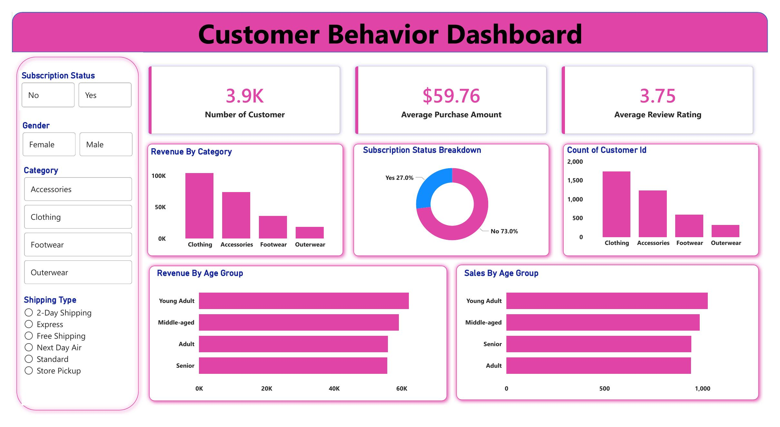

Dashboard Panel | Visualization | Key Insight
Revenue By Category | Bar Chart | Clothing leads; Outerwear is lowest
Subscription Status | Donut Chart | 73% Non-subscribers, 27% Subscribers
Customer Count by Category | Bar Chart | Clothing has highest customer count (~1,750)
Revenue By Age Group | Horizontal Bar | Young Adults top revenue contributor
Sales By Age Group | Horizontal Bar | Young Adults and Middle-aged lead in volume
KPI Cards | Metric Cards | 3.9K customers | $59.76 avg spend | 3.75 avg rating

The dashboard includes interactive filters for Subscription Status, Gender, Category, and Shipping Type, enabling drill-down analysis across all dimensions simultaneously.

6. Key Business Recommendations
# | Recommendation | Basis
1 | Target male customers with premium product lines | Males drive 68% of revenue
2 | Prioritize Clothing and Accessories inventory | Combined ~75% of total sales
3 | Launch subscription conversion campaigns for repeat buyers | Repeat buyers largely unsubscribed
4 | Offer express shipping upsells at checkout | Express buyers spend more on average
5 | Invest in cross-age marketing — all groups spend similarly | Balanced revenue across all age bands
6 | Focus on maintaining quality in Gloves, Sandals, and Boots | Consistently highest-rated products

Conclusion
This end-to-end analysis of 3,900 customer transactions — from raw data cleaning in Python, through SQL querying in PostgreSQL, to visual storytelling in Power BI — reveals a business where clothing dominates sales, male customers drive the majority of revenue, and subscription adoption remains an underutilized growth lever. The insights and recommendations in this report can directly inform product, marketing, and customer retention strategies.

— End of Report —

